Lappeenrannan Teknillinen Yliopisto

School of Engineering Science

Software Engineering

Software Development Skills: Front-end

LEARNING DIARY

Janne Pennanen

537026

**LEARNING DIARY**

30.10.2020  
  
I created a repository for the course, created a README-file and a couple of directories, one for exercises and one for the project I’m going to be coding in the future. Git as a whole isn’t something I’m particularly good at handling, but I know the basics. After downloading VS Code and installing some addons, it’s time to start the first video.

Whew, that was quite a ride. I have not done almost any JSON, SCSS or HTML before, so the first video was a bit of a culture shock. I got the hang of it in the end. I had to fiddle around with Node.js, npm and node-sass for a while since I encountered some problems, but I managed anyway.

I now have a workflow ready to go, and I have a basic grip on what’s going on.

20.11.2020

I finished the second video in the course material, which went a little more into detail with how SCSS/CSS and HTML works, and what kind of tricks one can do to make a website livelier. I am starting to get the hang of creating the website layout in HTML and modifying it to suit one’s needs through SCSS. During the second video I created a homepage for the website I’m building which contained my name, a short introduction and some text and icon links to other pages. What I found really exciting was how easy it is to use open-source icons, fonts, etc. I’m looking forward to continuing with the course, it’s been fun so far!

23.11.2020

I got into the third video, in which I was taught how to create transitions using a combination of HTML, JS and SCSS. Really interesting stuff, and really powerful. I, a complete simpleton when it comes to web development, threw together a smoothly animated rotating menu button withing 5 minutes! The power of mixins is something I’m starting to realize as well, since creating universal mixins to use with everything you need them for saves a lot of time compared to writing the same code again for every transition.

So far, I’ve been absolutely enjoying the course, the videos are really good and easy to follow. I’m happy that I chose this course!

24.11.2020

I watched the fourth video, during which I made animations for the navigation menu and its items. Again, I’m very impressed with how easy it is to create such elegant websites! I suppose we are dealing with rather high-level coding languages after all. I’m at the point where I can comfortably say that I know what’s happening during the videos and can start imagining how I would/will use the knowledge I’ve acquired for the course project by modifying the transitions used in the videos, for example. At this point I don’t really have any issues coding or understanding HTML or CSS anymore, at least I can handle the basics even if I don’t know the specifics of how the languages work. After the video, I fiddled around with the animations and customized them to my liking and to better fit my project.

26.11.2020

Fifth video in the books and feeling as good as after any other session of the front-end course. The videos are still very well put together and easy to understand. I feel like I know what I’m doing and why I’m doing it. This time I wrote html and SCSS/CSS for the About Me -page in the portfolio, in which the biggest difference compared to the main page was a CSS grid for different items in the page. CSS still amazes me in it’s power and simplicity, and a good example of that is how easy it is to put a grid together:

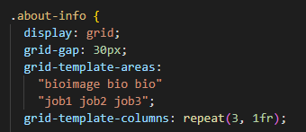

I mean seriously, after doing coding with lower-level languages (C), I’d never have thought these kinds of things could be so easy! Don’t get me wrong, I’m not saying C is a bad programming language, it is one of the most powerful and portable languages out there, but this is a change to say the least!

27.11.2020

After watching the sixth video, the initial website structure is complete. This is the point where I can start really making the website feel like my own. I’ll probably change some thins about the pages and their content, but it’ll stay as a portfolio website since I feel like some sort of customized portfolio might help me with job seeking in the future! What I learned during the sixth video was how to create a flexbox layout, which -again- was simpler than I had anticipated:

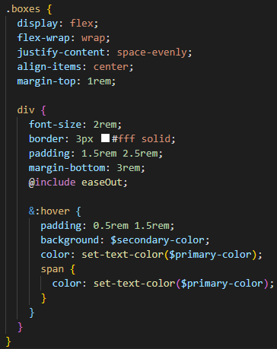

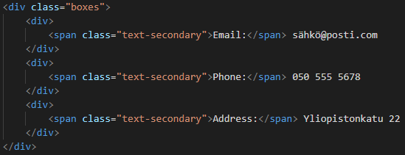

Something I find very effective is the use of the easeOut mixin and the set-text-color function that were written during the videos. They save a lot of time and are very simple to use. A clever way to limit the amount of code one has to write. I changed some of the padding and margin styling used in the video, because I feel like the website is more user-friendly and pleasing to the eye with the changes.